Health questionnaire for new patients

your full name
...........................................................................

female male
your address
...........................................................................
...........................................................................
...........................................................................
your postcode
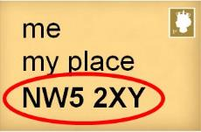 | ...........................................................................
your phone number(s)
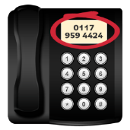  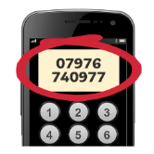 | home..................................................................  mobile.................................................................  work....................................................................
your date of birth
 | ...........................................................................
married or single
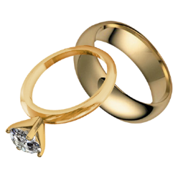 | I am married..........................................  I have a partner (not married)...............  I am single.............................................
do you have a job?
yes no

my job is.............................................................
how much do you weigh?
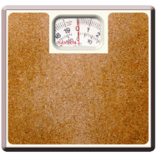  pounds | stone  2  kg
how tall are you?
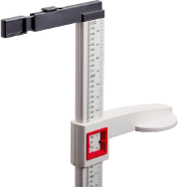  inches | feet  cm
your blood pressure
 | ...........................................................................
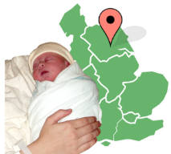
your place of birth (town | country)
 | ...................................|........................................
languages you speak
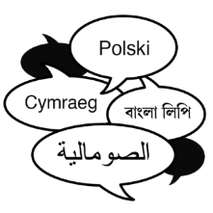 | your first language..............................................  other language(s)................................................  ............................................................................

your ethnicity (where your family is from)
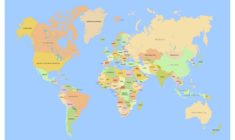 | ...........................................................................
do you need an interpreter?
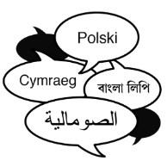 | yes no
if you are under 16 years old
name of your parent(s) or carer(s)

...........................................................................
their relationship to you
 | .........................................................................
the name of your school
 | ...........................................................................
if you are over 16 years old
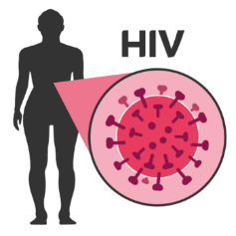 | you can have an HIV test – would you like to have one?  yes no
3
If yes, please let reception know and tell them if you would prefer to have the test at the Royal Free or the Whittington Hospital
- They will fill out a blood test form for you
- Take it the hospital you’ve chosen between 9am and 4.30pm, Monday to Friday, and they will take blood for the test

if you are over 16 years old
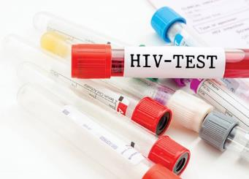 | you can have a sexual health test – would you like to have one?  yes no  If yes, please ask reception to book this with the nurse
if you are over 75 years old
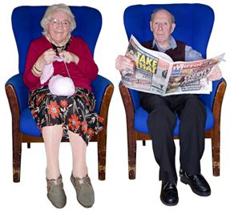 | you can have a health check – would you like to have one?  yes no  If yes, please ask reception to book this with the doctor and health care assistant (HCA)
next of kin details
name of your next of kin

...........................................................................

their contact details

...........................................................................

their relationship to you
 | .........................................................................
4

do you smoke?
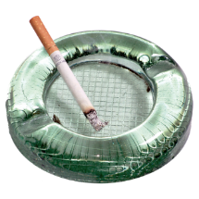 | yes no
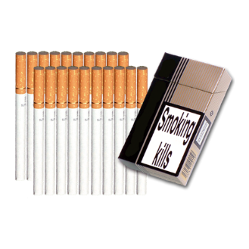
if yes, how many do you smoke?
cigarettes per day.............................

cigars per day...................................

other (e.g. pipe).................................

at what age did you start smoking?
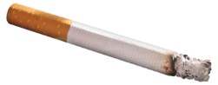 | years old
ex-smokers
at what age did you stop smoking?
 | . years old
how many did you smoke per day?
 | .................................................................
passive smoking
do people smoke around you?
at work yes no

at home yes no

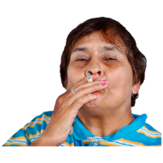
5
diet
6
do you add salt to your food after cooking?
 | yes no
do you have a varied diet that includes
milk, meat, vegetables and fruit?
 | yes no
has your cholesterol been checked in the
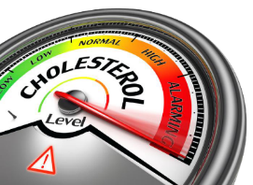
last 2 years?
 | yes no
exercise
do you take regular exercise?
 | yes no
if yes, what kind of exercise?
 | .................................................................
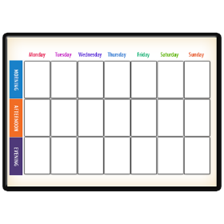
how many times per week?
 | .................................................................
allergies – are you allergic to anything?
(for example, food, medicines, bee stings)
 | yes no
if yes, please give details below
.................................................................
.................................................................
.................................................................
.................................................................

alcohol
alcohol unit information
 | 1 pint of beer or lager or cider = 2 units
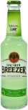 | 1 alcopop or 1 can of lager = 1½ units
 | 1 glass of wine (175ml) = 2 units
 | 1 single measure of spirits = 1 unit
 | 1 bottle of wine = 9 units
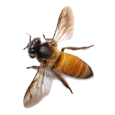
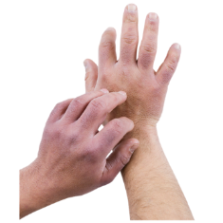
7

follow along the row to work out your score for each question and add this number to the last column | working out your score |  |  |  |  | your score
 | 0 | 1 | 2 | 3 | 4
how often do you have a drink that has alcohol in it? | never | once a month or less | 2-4 times per month | 2-3 times per week | 4+ times per week
how many alcoholic drinks do you have on a normal day when you are drinking? | 1-2 | 3-4 | 5-6 | 7-8 | 10+
how often do you have 6 or more alcoholic drinks on 1 occasion? | never | less than once a month | once a month | once a week | everyday or nearly everyday
how often in the last year have you found that you couldn’t stop drinking once you’d started? | never | less than once a month | once a month | once a week | everyday or nearly everyday
how often in the last year have you not managed to do what you were supposed to do because of drinking? | never | less than once a month | once a month | once a week | everyday or nearly everyday
has a family member/friend/doctor or worker been worried about your drinking or asked you to drink less? | no |  | yes but not in the last year |  | yes, during the last year
8
if your score is 5 or more, you may be drinking too much alcohol

please tell us about any medicines you
9
take (whether or not these are prescribed)
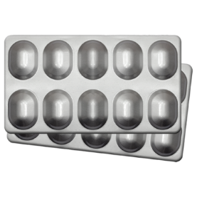 | name of medicine............................................  dosage (amount you take)...............................  name of medicine............................................  dosage.............................................................  name of medicine............................................  dosage.............................................................  name of medicine............................................  dosage.............................................................  name of medicine............................................  dosage.............................................................
female patients only
date of your most recent cervical smear
 | ........................................................................
where did you have the smear test done?
 | ........................................................................
what was the result of the smear test?
 | normal abnormal
pregnancy - please tell us about any
complications, miscarriages, terminations
.........................................................................
.........................................................................
.........................................................................
.........................................................................
.........................................................................
.........................................................................

what contraception are you using now?
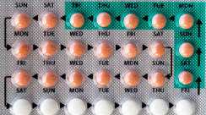  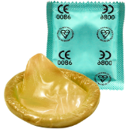 | .................................................................
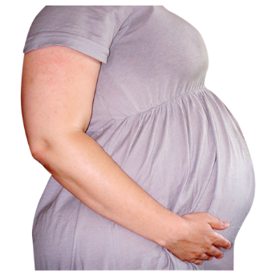
10

carers – do you have or need a carer?
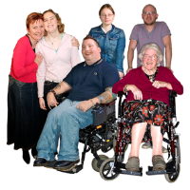 | yes no
if yes, would you like your carer to deal
with your health matters at the GP’s?
(the receptionist can help arrange this)
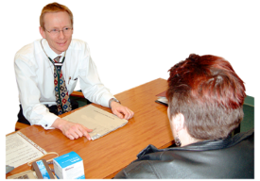 | yes no
are you a carer for anyone else?
yes no

if yes, ask the receptionist about support for carers

11

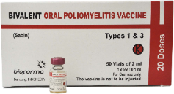
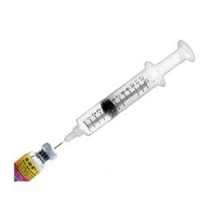
record of vaccination dates
type of vaccination | 1st | 2nd | 3rd | booster
Diptheria/Polio/HIB
Meningitis C
BCG
MMR
if MMR was given separately, please list details below
Measles
Mumps
Rubella (German Measles)
Tetanus
Typhoid
Yellow Fever
Cholera
Hepatitis A
Hepatitis B
Hepatitis C
please tell us about any other vaccinations below
12
your medical history
have you ever been admitted to hospital?
 | yes no
what were you in hospital for?
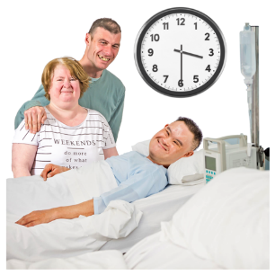 | .........................................................................  .........................................................................  .........................................................................  .........................................................................  .........................................................................
please tell us about any treatment you’ve had for chronic (long-term) conditions
.........................................................................
.........................................................................
.........................................................................
.........................................................................
.........................................................................

13

X-rays, scans, ultrasound, mammogram
Please give dates below
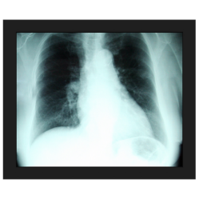  X-rays | .........................................................................  .........................................................................  .........................................................................  .........................................................................  .........................................................................
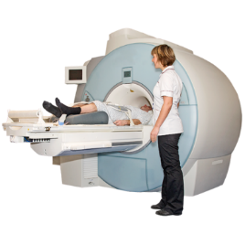  MRI scans | .........................................................................  .........................................................................  .........................................................................  .........................................................................  .........................................................................
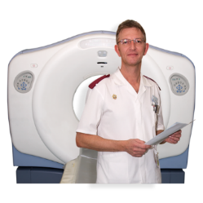  CT scans | .........................................................................  .........................................................................  .........................................................................  .........................................................................  .........................................................................
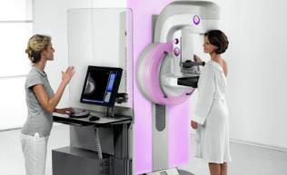  Mammogram | .........................................................................  .........................................................................  .........................................................................  .........................................................................  .........................................................................
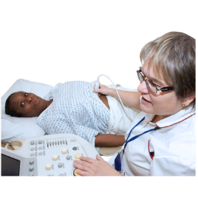  Ultrasound | .........................................................................  ......... ................................................................  .........................................................................  .........................................................................  .........................................................................
14
your family history
is there any of the following in your family (mother, father, sister, brother) before the age of 65?
heart disease (heart attacks, angina)
yes no

which family member?.......................................

stroke
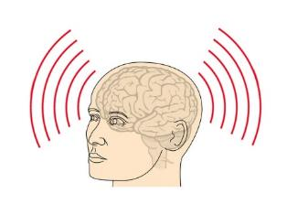 | yes no  which family member?.......................................
asthma
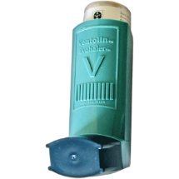 | yes no  which family member?.......................................
diabetes
yes no

which family member?.......................................

cancer
yes no

which family member?.......................................
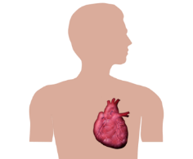
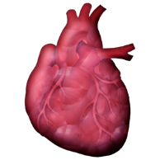
15

high blood pressure
yes no

which family member?.......................................
tuberculosis (TB)
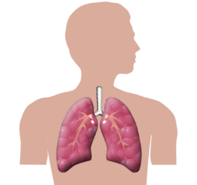 | yes no  which family member?.......................................
other serious illness
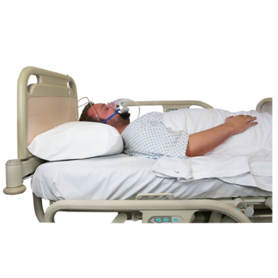 | yes no  which family member?.......................................  what illness?......................................................
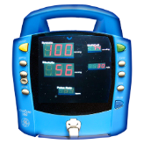
16

Thank you for filling in this health questionnaire
- Please book an appointment for a new patient health check with the health care assistant (HCA)
- After you have registered, please ask reception to give you patient online access details

